October 27, 2005

VIA FACSIMILE
The Honorable Dr. Condoleezza Rice
Secretary of State
U.S. Department of State
Washington, DC 20520

Re: Meeting with Turkish Cypriot Leader Mr. Mehmet Ali Talat

Dear Secretary Rice:

I am writing on behalf of the American Hellenic Educational Progressive Association (AHEPA), the nation’s largest and oldest American-based Greek heritage grassroots membership organization, on the occasion of your meeting with Turkish Cypriot Leader Mr. Mehmet Ali Talat.

While our organization has a recent history of encouraging rapprochement and reconciliation in the Eastern Mediterranean of which we are proud, we are deeply concerned about current United States policy toward the Republic of Cyprus and its implications for a just and viable solution to the 31-year-old division of the island. Among the recent actions taken by the United States government that are unacceptable include:

- the visit of the Transportation Security Administration officials to the occupied airport of Tymbou (October 2004), and
- the encouragement of members of the U.S. Congress and their staffs to travel and enter Cyprus through illegal ports of entry (May and August 2005).

We contend that these detrimental actions taken by the United States, and others, are the result of the defeat of the April 2004 referendum on the Annan Plan by the citizens of the Republic of Cyprus. It was not a vote against reunification. The plan simply was unbalanced in the minds of the voters. As the President of the Republic of Cyprus, Tassos Papadopoulos clarified: “The most serious of them [inaccuracies] is the erroneous interpretation of the choice of the Greek Cypriot community at the referendum of April 24, namely, that by the disapproval of this specific Plan, Greek Cypriots have voted against reunification of their country.”
Secretary Rice, you stated the following in an interview with Mr. Tim Russert on Meet the Press, October 16, 2005, in regard to a “what if scenario” if the constitutional vote in Iraq failed:

“Tim, it's an argument I don't understand. If it passes, then democracy has been served. If, for some reason it does not, then democracy has been served. It would be like saying that a referendum in the United States, because it didn't pass, that it somehow was against the democratic process.”
American citizens of Cypriot and Greek heritage respectfully request that the United States applies the

Letter Re: Visit of Mr. Ali Talat—Page 2
same rationale to the Republic of Cyprus and its citizens who voted on a referendum about their country’s future in the same democratic process as the citizens of Iraq.

In conclusion, we believe your meeting with Mr. Ali Talat will elevate the status of an illegally formed entity in occupied Cyprus, and in essence, will encourage a separatist path for the Turkish Cypriot community to follow. This is a path condoned by Turkish Prime Minister Recep Tayyip Erdogan who stated: “During my meeting with Greek Cypriot leader Tassos Papadopoulos, I told him that they should accept two states in northern and southern Cyprus and one confederative structure within the scope of Annan Plan, otherwise, agreement is impossible.”

Obviously, this course is not in the best interest of U.S. policy in the Eastern Mediterranean and not conducive to a bizonal, bi-communal federal solution to the Cyprus problem.

Respectfully submitted,
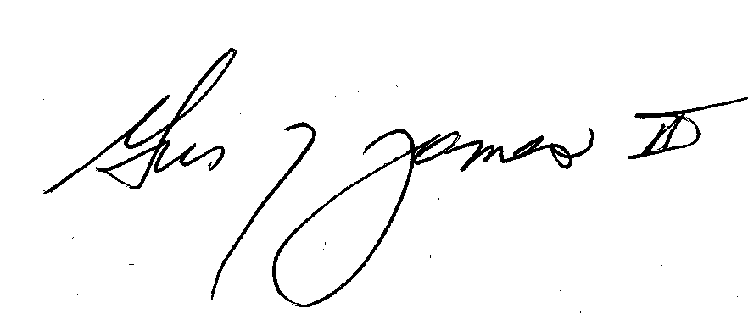
Gus J. James
National President

Letter written by President of the Republic of Cyprus Tassos Papadopoulos to United Nations Secretary-General Kofi Annan, June 7, 2004.
“Mr. Erdogan discloses his brief dialogue with President Papadopoulos.” Ankara Anatolia News Agency, September 19, 2005.

