Η ΠΟΛΗ ΠΑΡΘΗΚΕ

Η επίθεση ορίστηκε για την νύχτα της 29^{ης} Μαΐου. Ύστερα από διαταγή του Αυτοκράτορος θρησκευτικές πομπές τις οποίες ακολουθούσε ένα τεράστιο πλήθος ανθρώπων που έψαλλε το «Κύριε Ελέησον», πέρασαν κατά μήκος των τοιχών της πόλεως. Η μεγάλη ακολουθία εκείνης της βραδιάς ήτο η τελευταία Χριστιανική ακολουθία που έλαβε χώρα στην εκκλησία της Αγιάς Σοφιάς. Κωνσταντινοπολίται, Ενετοί και Γενουάτοι ήσαν όλοι παρόντες. Ο Αυτοκράτωρ και η ακολουθία του μετέλαβαν των Αχράντων Μυστηρίων και απεχαιρέτησαν τον Πατριάρχη. Η ιερή ακολουθία στην πραγματικότητα ήταν η επιθανάτιος λειτουργία.

«Ουαί την Πόλιν σοι δούναι ούτε εμόν εστίν ούτε άλλων των κατοικούντων εν αύτη. Κοινή γαρ γνώμην πάντες αυτοπροαιρέτως αποθανούμεν και ου φεισόμεθα της ζωής ημών...» Αυτά είπε ο Αυτοκράτωρ.

Στο μεταξύ κολλήσανε στο κάστρο ένα σμάρι Τούρκοι και πηδήξανε μέσα στην Τάμπια τσαλαπατώντας ο ένας τον άλλον και πλημμάρανε σαν τη θάλασσα που ρίχνει χάμω το μόλο...και η καστρόπορτα άνοιξε και η μερμηγκιά χίμιζε μέσα σε φοβερή οχλοβοή.

Εκείνη την ώρα ακούστηκε μια φωνή: η Πόλη επάρθηκε...Κοντά στην Πόρτα του Αγίου Ρωμανού την Τρίτη το πρωί, 29 Μαΐου 1453 παρέδωσε την ψυχή του ο Μάρτυρας Βασιλιάς κράζοντας με δάκρυα: «Δεν υπάρχει Χριστιανός να κόψει την κεφαλή μου»;

Την ώρα που γινόταν στην Καστρόπορτα του Ρωμανού αυτός ο θρήνος, μέσα η πολιτεία ήταν έρημη. Μέσα στα βουβά μεϊντάνια και στους δρόμους ακουγότανε μοναχά η φωνή: η Πόλη πάρθηκε, η Πόλη πάρθηκε...Όλοι τρελαθήκανε ακούγοντας αυτή τη φωνή να κράζει με θρήνο...η Πόλη πάρθηκε, η Πόλη πάρθηκε, η Πόλις Εάλω...

Γιατί πουλί μ’ δεν κελα…..δεν κελαηδείς
Πως κελαηδούσες πρώτα
Για πώς μπορώ, μπορώ να κελαηδώ.

Με κόψαν τα φτερούδια, φτερούδια μου
Με πήραν τη λαλιά μου
Μας πήρανε μπρ’ αμάν την Πόλη μας

Μας πήρανε την Πόλη, την Πόλη μας
Και την Αγιά Σοφιά μας
Επικράθη η Παναγιά

THE CITY HAS BEEN ΤΑΚΕΝ

The attack was set for the evening of May 29th. Following the Emperor’s orders religious processions followed by a huge crowd of people chanting “Lord have mercy,” passed along the walls of the City. The huge service of that night was the last Christian service that took place in the church of Hagia Sophia. Konstantinopolitans, Venetians and Genoese were all present. The Emperor and his entourage received Holly Communion and bid their farewell to the Patriarch. This service was in actuality a memorial service.

“Alas the City we give you it is neither mine, nor anyone’s who is inhabiting it. It is our own mutual decision to die and not to consider our life…” That is what the Emperor said.

In the meantime a multitude of Turks seized the walls and jumped into the city, one stepping upon the other, flooding the city like a ferocious sea storm that thrusts the dock down…and the castle door opened and the ant-like multitude rushed in amidst an atrocious uproar.

During that time a voice was heard: the City has been taken…Near the Door of St. Romanos, on Tuesday morning, May 29 1453, the Martyr King left his last breath, crying out: “Isn’t there a Christian to cut my head off?”

While these tragic events were taking place at the Romanos’ Castle Door the city center was deserted. In the city center squares and streets only a voice was heard: the City has been taken, the city has been taken …everyone was crazed listening to this lamenting voice crying: the City has been taken, the city has been taken …

Why my bird you don’t sing
As you were singing before?
How could I, could I sing

They cut off my wing tips
They took my song voice away
They took “mbr’ aman” our City (Konstantinople)

They took our City, our City
And our Hagia Sophia
Embittering the Panagia (Virgin Mary)

Transcription, translation and layout by Nina & Bill Gatzoulis
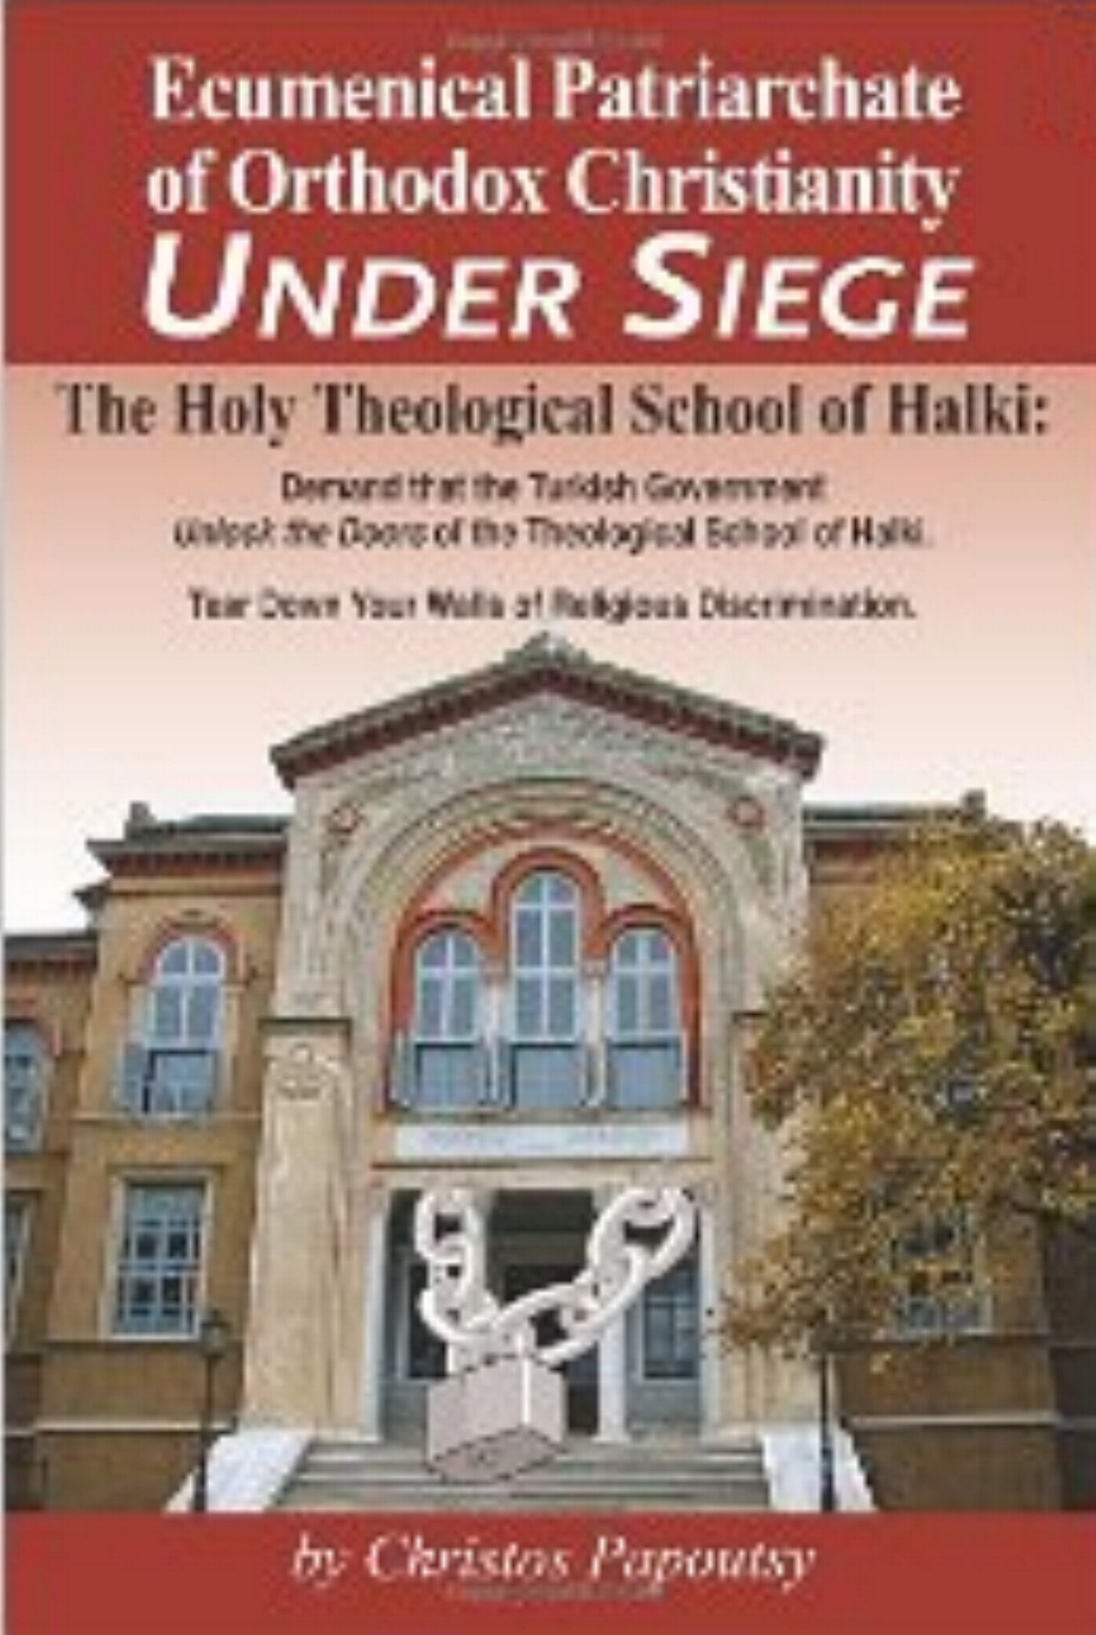

"I just finished reading your latest book Ecumenical Patriarchate of Orthodox Christianity UNDER SIEGE. Stylishly written and overflowing with drama, pathos, and love, here is a matchless account and history of a forgotten Orthodox microcosm of Byzantium, Halki. The information and many documents which you have presented will certainly influence the international powers to enlighten the Turkish government to "Unlock the Doors of the Theological School of Halki." Congratulations!"--Professor Emeritus John C. Rouman.

This newly released book can be purchased online at www.amazon.com.
ISBN: 14528202
Softcover: 277pp; Price $20.00

To schedule a book presentation by the author,
email to PapcoHolding@papcoholdings.org
“Ecumenical Patriarchate of Orthodox Christianity UNDER SIEGE”
by Christos Papoutsy
This newly published book, the only one of its kind, covers the complete history of the Theological School established on October 1, 1844 through 1971, when the school was closed by the Turkish Government. Despite occasional promises by the Turkish authorities to reopen the facility, the school has remained closed.
It took over two years of worldwide research to uncover and document the complete story covering the history of the Halkitou Monastery from 809-811 to the establishment of the Theological School in 1844 to the closing in 1971 in the effort to reopen through 2010.
This book reviews the violations of the Lausanne Treaty signed by Turkey and Greece in 1923, establishing the rights of minorities in Greece and Turkey set forth in Article 37 agreeing to Freedom of Religion which Turkey has violated hundreds of times. The book covers the history of the Holy Trinity Patriarchal and Stavropigio Monastery and the Theological School.
Included in this publication is a treasure trove of history of the facilities, world class Library, and all the Abbots. It also provides the complete history and documentation of most of the resolutions, partitions, surveys, and statements from governments and churches from around the world.
It also explores the legal possibilities for the CALL OF ACTION against the government of Turkey for its closure of the Halki School of Theology.
In an attempt to understand some of the Turkish government’s philosophies and points of view toward the continual closure of the Holy Theological School of Halki, the author includes materials to present a fair and balanced version.
This publication is part of a more general effort to make available to the public archival and current materials offering a complete picture of the entire history through 2010.
This publication on the specific subject of the history, closing, and post closing of the Holy Theological School of Halki and offers value for discussion on broader themes such as a foundation for additional research. This publication of primary sources can serve as an excellent starting point for future research and discussion, since the school’s important internationally make it a particularly suitable subject for religious, political, legal, and diplomatic topics.
The closure of Halki occupies an important position within a broader, global discussion on religious discrimination and freedom. Above all, it is the author’s hope that readers will have a clearer understanding of the history of the Holy Trinity School and Halki and the plight of the “Ecumenical Patriarchate of Orthodox Christianity Under Siege.”
Ultimately, the author believes it is incumbent upon all of us, members of the world community, to become educated about matters of prejudice and repression and to support their elimination everywhere.
Finally, the author’s message to the Turkish Government: Tear Down Your Walls of Religious Discrimination.

