Published ELT News, Feb 2009

Venizelos bed retires to Greece
By Andrew Leech (aleech@ath.forthnet.gr)

In March 2004, nearly 78 years to the day Eleftherios Venizelos died on it, the finely carved mid-nineteenth century bed, with a rather hard, but not unpleasant mattress, that had shared so many of the statesman’s late night agonies, thoughts and dreams made its way from Paris to Athens. It had been a long journey, over the years. First, from France to Britain, then back to France and finally to Greece.

Helena Venizelou, the London born and educated daughter and heiress of wealthy shipping magnates John and Virginia Schilizzi had married Eleftherios Venizelos in 1921, the ceremony taking place at Witanhurst, Highgate, the London estate of Sir Arthur Crosfield, the Baronet and Member of Parliament who had married Dominie Iliadi, the daughter of Helena’s best friend, Marika Omirou-Iliadi (to whom the Athens Maternity Home is dedicated). [Note: Dominie Crosfield had been the link between Venizelos and British Prime Minister Lloyd George during WW1 and, as the latter’s Balkan Advisor, had been a party to drafting the agreement by which Greece would have had the town of Smyrni –and 30 klm surrounding on all sides – as a colony, subject to a plebiscite. Lord Curzon wrote of her: “that woman has a devilishly political mind.”]

Helena’s wealth had enabled her to keep residences in Athens and Kifissia, Paris and London and these houses were tastefully decorated and furnished according to her own specifications and had proved the perfect bases and backdrops to the era when Venizelos had been struggling to drag Greece into the political limelight as a player of some consequence. They had been bases from which he could launch his dreams of regaining land, honour and power for his beloved Greece.

Strangely enough two of these houses still fulfil political roles. The Athens house at 2 Loukianou St was sold to the British government in 1933 – actually a protest against the assassination attempt on her husband’s life, when Helena decided she didn’t want Greece to have this house – and it became the British Ambassador’s Residence. The London residence at 51 Upper Brook St, Mayfair, in contrast, was later given to Greece and became the Greek Ambassador’s Residence, George Seferis (the poet) being its first occupant.

The French residence at 22 rue Beaujon, near the Etoile in the fashionable 16th quarter, though, where Helena lived next door to her friend Mrs Dolly Papalexopoulou, is the one that interests us, at present; as it was here that Eleftherios Venizelos spent the last period of his life in exile and finally died.

The great statesman was found early on the morning of 18th March 1936 by the servant bringing his usual coffee. He had died in his sleep and, with his death, an important era for Greece ended. From then on, for several years, his room was kept as a shrine by Helena, in memory of her much loved husband.

After the rue Beaujon house was closed, Helena wanted certain items of furniture preserved. The bed was sent to Highgate, London, in the custody of Lady Crosfield, with instructions that it should be transferred to Marina Sacopoulou (a great friend of Helena’s since 1924) as soon as was practicable. This transfer took place in March 1965, according to the extant documents that show its carriage from London to Paris where Marina Sacopoulou lived and worked as a Byzantist for the College de France and consultant for the Louvre Museum.

The Venizelos bed remained in Marina’s Avenue Felix Faure flat till 1991. Then it moved to another flat in Rue Letellier (a nearby street) until 2004, when it was shipped back to Greece. It now resides in an Athens flat, in the suburb of Halandri.

Prior to the Athens Olympic Games, Dora Bakoyianni had been interested in displaying it at the Athens Town Hall, however, for logistical reasons this did not take place.

See Photos Below:

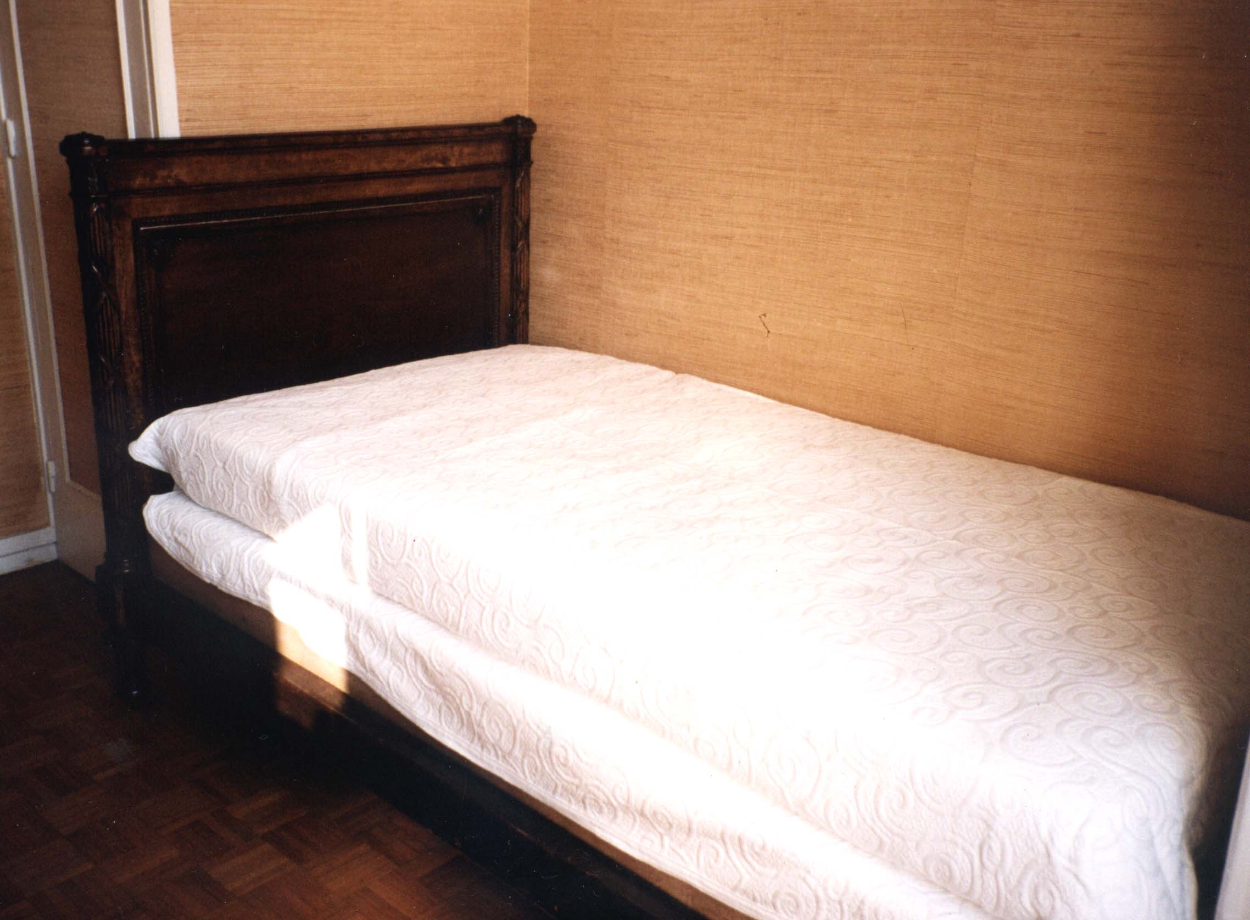
Full bed

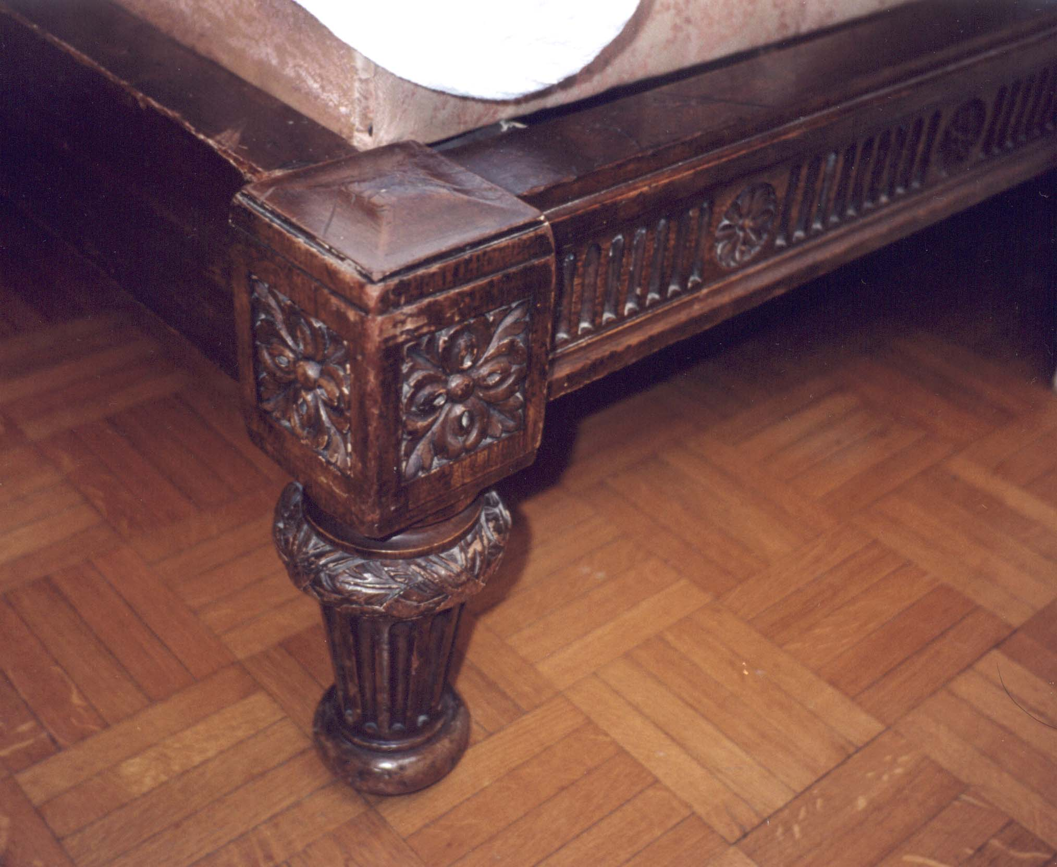
Carved leg of bed

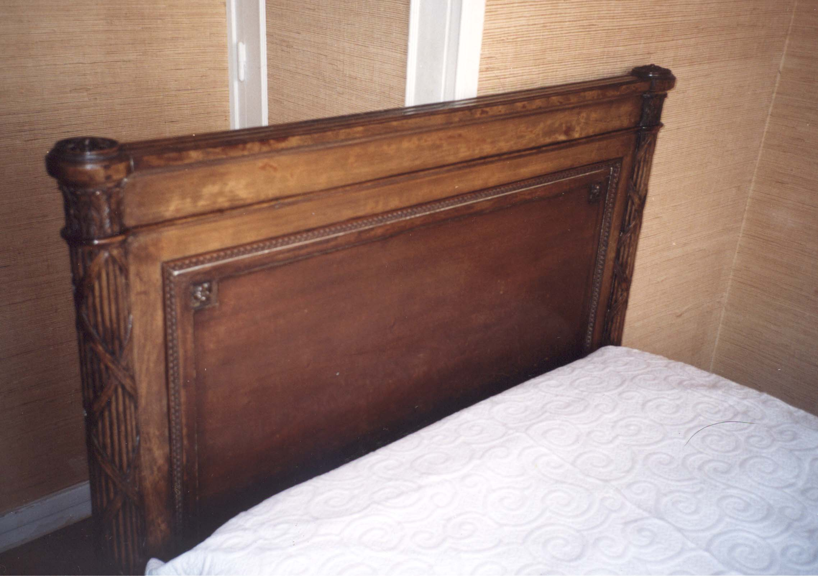
Carved bedhead

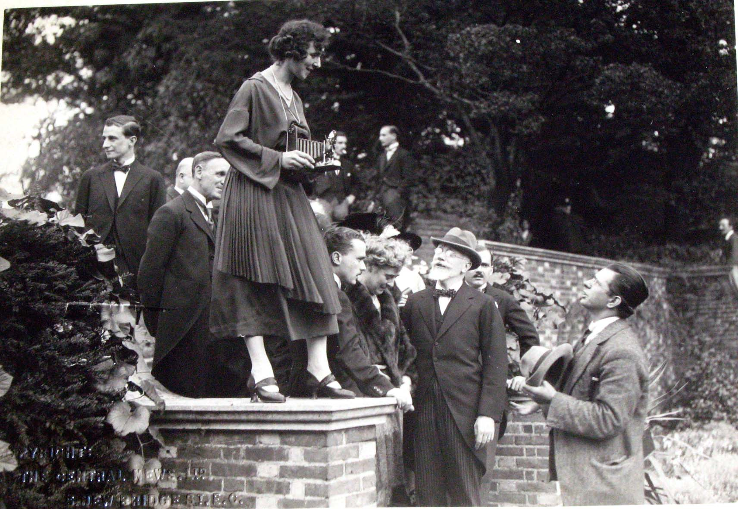
Venizelos Wedding at Highgate, Dominie Crosfield standing on wall

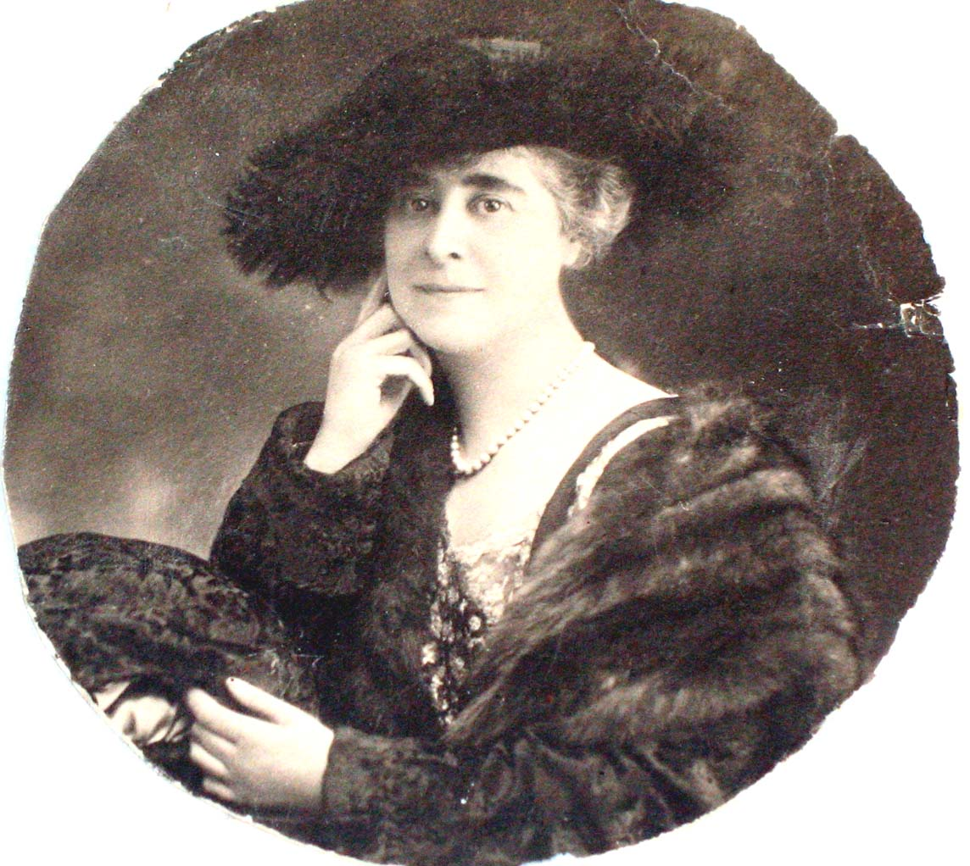

Helena Venizelou circa 1900 (circular photo)

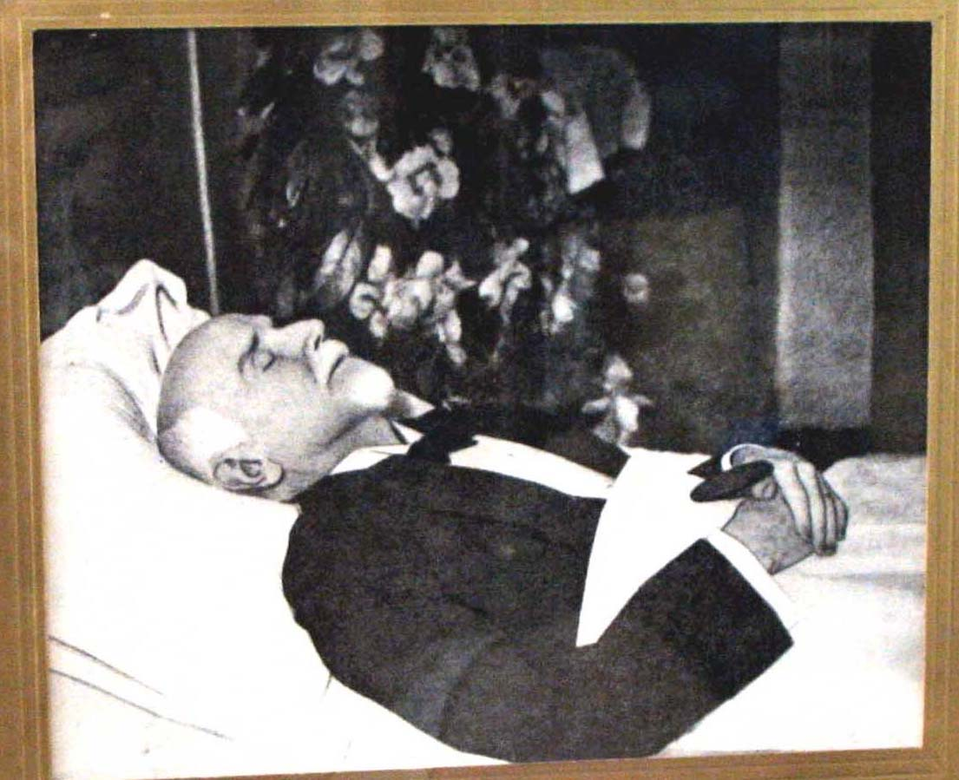
E. Venizelos: lying in state in his bedroom

