CALLING ALL TURKS & FRIENDS OF TURKEY
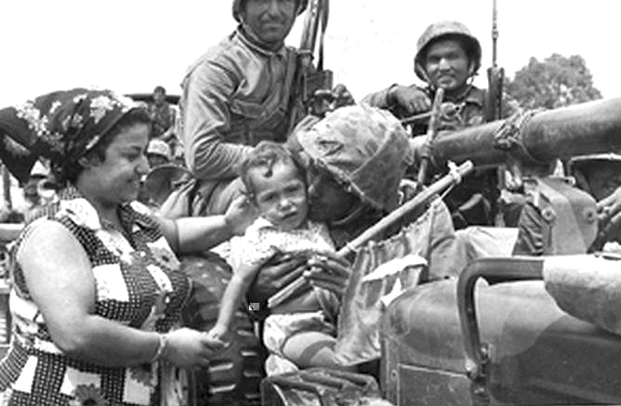
VIGIL FOR FREEDOM OF
TURKISH CYPRIOTS

Sunday, July 19, 2009 / 6:00pm to Monday, July 20, 2009 / 12:00pm

IN FRONT OF THE TURKISH EMBASSY, DC
2525 Massachusetts Avenue, N.W., Washington, D.C 20008

Assembly of Turkish American Associations (ATAA) is leading a VIGIL to respond to the extremist Cyprus Action Network of America (CANA). We will always be grateful to the Turkish Armed Forces for the Cyprus Peace Operation of July 20, 1974 which stopped the savage ethnic cleansing of the Turkish Cypriots by Greek Eoka guerrillas.

Please contact us at 202.483.9090 or 240.888.2860 and let us know you are coming.

